Major :
Research Topic : (Refer to Research Roadmap)
Research Roadmap Topic from FM : (Topic will be decided by FM)
SDG Goals : (Choose one goal from the 17 SDG Goals)
BINUS
<<EXCELLENT/ SERVING THE NATION / ENVIRONMENTAL CARE/ PROFESSORSHIP >> RESEARCH PROPOSAL



RESEARCH TITLE

Research Leader | Lecturer Code
Research Member 1 | Lecturer Code
Research Member 2 | Lecturer Code
etc. | etc.

Major
Faculty BINUS UNIVERSITY
Month Year

BINA NUSANTARA UNIVERSITY RESEARCH APPROVAL SHEET

Research Title | :
Research Scheme | : BINUS <<Excellent/ Serving the Nation / Environmental Care /Professorship>> Research
Year of Funding | :
Duration | :
Field of Research* | :
Sub Fields of Research** | :
Social and Economic Purpose*** | :
Sub Social and Economic Purpose**** | :
RIG Member | :
Proposed Funds | Year 1: Rp ………….
 | Year 2: Rp …………. (Excellent Research Only)
 | Year 3: Rp …………. (Excellent Research Only)
Partnership Funds | : Rp …………. | Institution/Country of Origin:
Research Leader | : | Lecturer Code : | Major:
Functional Position | : | Contact Number: | Email:
Member 1 | : | Lecturer code : | Major:
Member 2 | : | Lecturer Code : | Major:
Member 3 | : | Lecturer Code : | Major:
Student Name | : | NIM: | Major:

Jakarta, dd-mm-yy

Proposed By,  Research Leader  Tanda tangan  Name  Lecturer Code | Reviewed By,  Research RC/PIC  Tanda tangan  Name  Lecturer Code
Acknowledged,  Dean  Tanda tangan  Name  Lecturer Code | Approved,  Vice Rector V – Research & Technology Transfer  Tanda tangan  Prof. Dr. Tirta Nugraha Mursitama, S.Sos., M.M., Ph.D.  D4645

RESEARCH TEAM AND GENERAL RESEARCH DESCRIPTION

- Research Title :
- Research team Identity :
No | Name | Position | Specialty | Time Allocation (hour/week)
1 |  | Leader
2 |  | Member 1
3 |  | Member 2
4 |  | Member 3
5 |  | Student
- Research Object (Type of Material that would be observed)
- Duration of Research
Start | Month : | Year :
Finish | Month : | Year :
- Proposed PT Funds: Rp. ……………..,-
- Research Location (Lab/Studio/Field)
- Involved Institutions (If there is an involved institutions (Hospitals, Laboratory, Corporation who provides data and contributed to the research), explain their contribution)
- Results of the Study/Target (Product or Idea to Support the policy )
- Contribution for a certain field of study/science (Less than 50 words, focus on the research’s original and fundamental idea for the improvement of study/science)
- Target For Scopus Publication :
No. | Publication Name  (Conference/International Scopus Indexed Journal) | Estimated Year of Publication
1.
2.
dst.

- Additional Output Target :
No. | Additional Output Target  (HKI/Book/Prototype/Other (kindly elaborate))  *Scratch One | Estimated Year of Achievement
1.
2.

SUMMARY

Describes the background and the main purpose of the research, as well as the methods that will be implemented in conducting the research. The abstract should describe the activity that will be conducted during the research

Keywords:

ABSTRACT

Keyword:

TABLE OF CONTENTS
<<Proposal>>

Title Page
Bina Nusantara University Research Approval Sheet
Research Team and General Research Description
Summary and Abstract
Table of Contents
List of Images
List of Tables
Chapter 1. Introduction
Chapter 2. Literature Review
Chapter 3. Aim and Objectives
Chapter 4. Research Method
Chapter 5. Research Budget
Chapter 6. Activities Planning
References
Lampiran
- Letter of Aggrement for Research Collaboration (Mandatory for BINUS Excellent Research)
- Research Task Description
- Research Leader and Members Identity
- Research Roadmap

LIST OF IMAGES

LIST OF TABLES

CHAPTER 1. INTRODUCTION

Describe the background and problems would be studied, the specific objectives, and the urgency (priority) of the research. Also explain the targeted findings / innovations and their application in order to support the development and development of science, technology, social and cultural affair. Create an annual achievement plan as shown in Table 1a – Table 1c in line with the target output and the duration of research.
Table 1a. BINUS Serving the Nation Research Scheme Target Output per Year

No. | Mandatory Output | Type of Output* | Minimum Target
1. | International Publication From Scopus | Journal/Conference | Conference :Accepted  Journal : under review content
2. | International Publication From Scopus | Journal/Conference | Seminar:Accepted  Jurnal: under review content
3. | Innovation Product | Research Results  (Product, Application, platform, system atau Social Engineering) | Implementation of the Product In Indonesia
4. | Enrichment | Teaching/P2M/Training(Book Chapter/ slide ppt) | Approved
5. | Intellectual property Rights (HKI) | Patent/Simple Patent/ Copyright/ Trademark/ Confidential Business/ Product Industry Design/ Geographical Indication Plant Breeder’s Right/ Integrated Circuit of Topography | Registered
6. | Proof of Research Product | Model/Prototype/ Design/Art/ Social Engineering | Upload on the provided page
7. | Poster Produk | Poster that depicts the product of The Research | Upload on the provided page
* Pick One
Table 1b. BINUS Environmental Care Research Scheme Target Output per Year

No. | Mandatory Output | Type of Output* | Minimum Target
1. | International Scopus Publication | Journal/Conference | Conference :Accepted  Journal : under review content
2. | Enrichment | Teaching/P2M/Training/Book Chapter/ slide ppt) | Approved
3. | Proof of Research Product | Model/Prototype/ Design/Art/ Social Engineering | Upload on the Provided Page
4. | Poster | Poster that depicts the product of The Research | Upload on the Provided Page
5. | Innovation Product | Reseach Product (Product, Application, Platform, system atau Social Engineering) | Implementation of Product within Binus Environment
* Pick One
Tabel 1c. BINUS Excellent Research Scheme Target Output per Year
No. | Mandatory Output | Type of Output* | Minimum Target
No. | Mandatory Output | Type of Output* | Year 1 | Year 2 | Year 3
1. | International Scopus Publication | Journal (Q2 – Q4) /Conference | - Conference: Accepted  -Journal : under review content | -Conference :Accepted  -Journal : under review content | -Conference :Accepted  -Journal : under review content
2. | International Scopus Publication | Q1 Journal | Under review content |  | Under review content
3. | Enrichment | Teaching/P2M/Training(Book Chapter/ slide ppt) | Approved
4. | Poster | Poster that depicts the product of The Research | Upload on The Provided Page
5. | Intellectual property Rights (HKI) | Patent/Simple Patent/ Copyright/ Trademark/ Confidential Business/ Product Industry Design/ Geographical Indication Plant Breeder’s Right/ Integrated Circuit of Topography | Registered
6. | Proof of Research Product | Model/Prototype/Design/Art/ Social Engineering | Upload on the provided page
7. | Product that will ready to be commercialized /implemented in the society | Research Product | Implementation of Product in Indonesia

* Pick One

CHAPTER 2. LITERATURE REVIEW

Describe the State of the art from the field of study that will be observed. Use the latest and most relevant reference library that focuses on the result in a scientific journal.
Researchers should mention a previous study that has been conducted which includes its research roadmap.

CHAPTER 3. AIM AND OBJECTIVES

This chapter describes the Aim and Objectives of the research

CHAPTER 4. RESEARCH METHOD

Research method should include a Fishbone Diagram charts which pictures the activity that will be conducted during the research and the duration of the activity. The chart should be structured thematically and describes the complete aspects of the research from the activity of the research step by step, where the research will begin, the location of the research and the indicator of what the research should achieve.

CHAPTER 5. RESEACH BUDGET

  - Budget Summary
The summary of Research Budget must be in accordance format shown in table 2

Table 2. Yearly Research Budget
        - Components
Sub Components* | Item | Unit | Volume | Unit Price (Rp) | Total costs (Rp)
Subtotal (Rp)
        - Data Collection
Sub Components* | Item | Unit | Volume | Unit price (Rp) | Total costs (Rp)
Subtotal (Rp)
        - Equipment
Sub Components* | Item | Unit | Volume | Unit Price (Rp) | Total Costs (Rp)
Subtotal (Rp)
        - Data Analysis
Sub Components* | Item | Unit | Volume | Unit Price (Rp) | Total Costs (Rp)
Subtotal (Rp)
        - Mandatory and Additional outputs report
Sub Components* | Item | Unit | Volume | Unit Price (Rp) | Total Costs (Rp)
Subtotal (Rp)
Total Required Budget (Rp)

Table 3. Research’s Sub Component
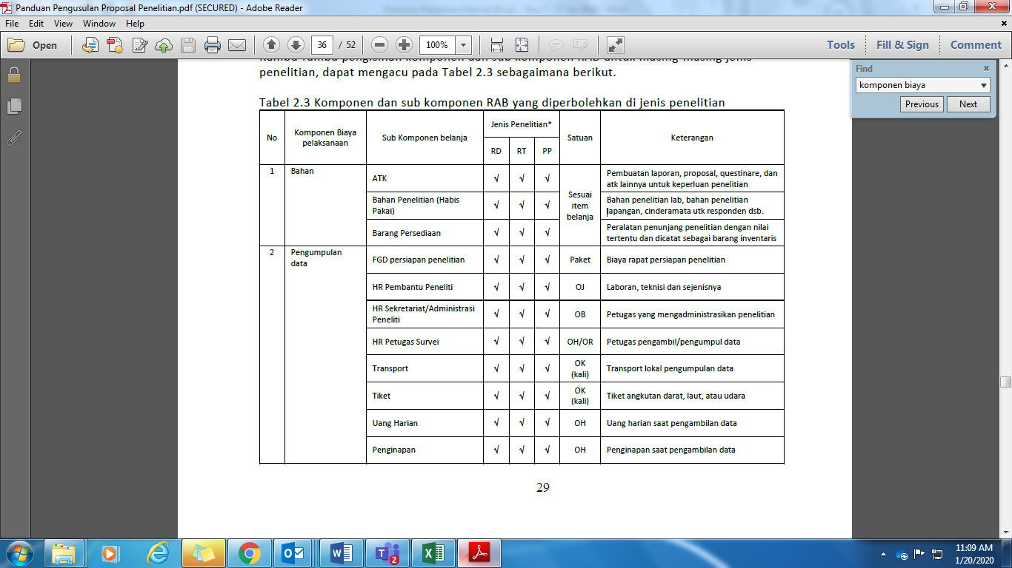
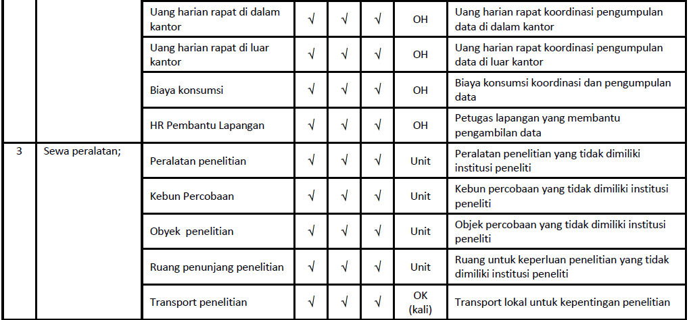

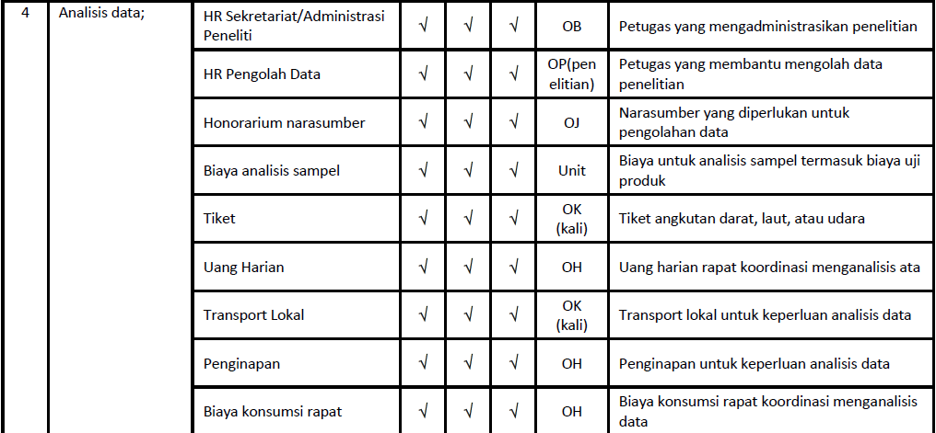
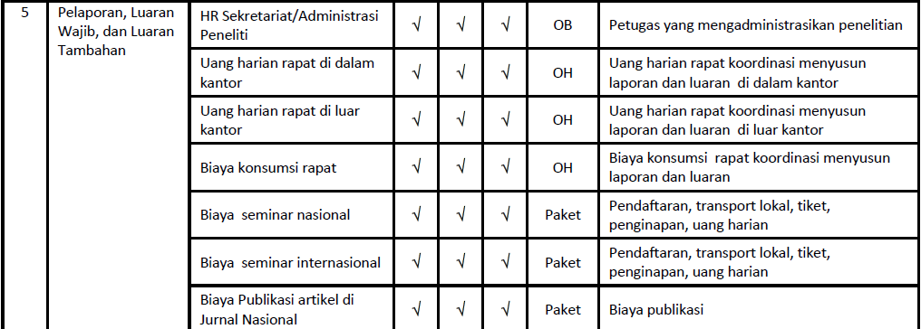
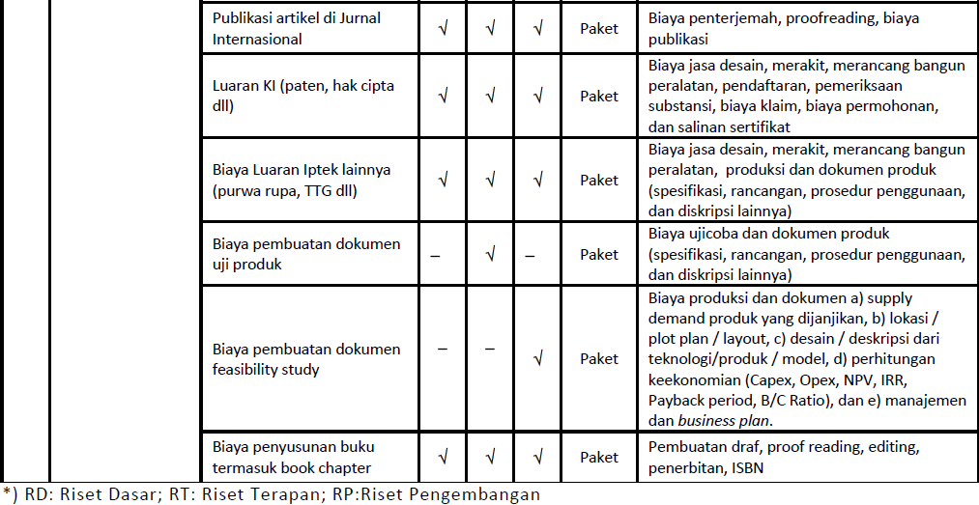

(Source: Panduan Pelaksanaan Penelitian dan Pengabdian Kepada Masyarakat
di Perguruan Tinggi Edisi XII Tahun 2018 Revisi 2 Tahun 2019)

CHAPTER 6. TIMEFRAME AND WORKPLAN

  - Research Schedule
Research schedule should be arranged in line with the proposed research plan as shown in Table 4.
Table 4. Annual Research Schedule
No | Type of Activites | <<Year>>
No | Type of Activites | 1 | 2 | 3 | 4 | 5 | 6 | 7 | 8 | 9 | 10 | 11 | 12
1 | Activity 1
2 | Activity 2
3 | …………
4 | …………
5 | …………
6 | Activity-n

REFERENCE

References should be written in line with the name, year system and the order of reference. Only the Cited References that should be included in the Reference section.

APPENDIX

RESEARCH TEAM ORGANIZATION AND TASKS
No | Name | Lecturer Code/NIM | Field of study | Time Management | Task
1 | Leader
2 | Member 1
3 | Member 2
4 | Member 3
5 | Student

RESEARCH TEAM PROFILE

Research Leader/Members Profile
- Profile
1 | Full Name ( with title)
2 | Gender |  | M/F
3 | Position
4 | Employee ID/NIN
5 | NIDN
6 | Date and Place of Birth
7 | E-mail
8 | Handphone
9 | Office Adress
10 | Phone Number
11 | Graduates Produced |  | S-1 = … Students; S-2 = … Students; S-3 = … Students
12 |  | Course/field of study where the member is a lecturer | 1
 |  | Course/field of study where the member is a lecturer | 2
 |  | Course/field of study where the member is a lecturer | 3
 |  | Course/field of study where the member is a lecturer | etc.

- Education Profile
 | S-1 | S-2 | S-3
University
Field Of Study
Date of enrollment – Graduation
Title of Thesis
Supervisor

- Research Experience in the last 5 years (non Thesis)
No. | Year | Title | Budget
No. | Year | Title | Source* | Total Cost Rp)
1
2
3
etc.
* Be sure to mention the main source of the budget, whether it is come from DRPM or any other source.

- Community Service experience in the last 5 years
No. | Year | Community Service name | Budget
No. | Year | Community Service name | Source* | Total (Million)
1
2
3
etc.
* Mention the source of the budget, whether it is come from DRPM or any other source

- Scientific Article publication in a journal in the last 5 years
No. | Scientific Article Title | Journal Name | Volume/Year
1
2
3
etc.

- Science Conference’s public speaker in the last 5 years
No | Conference name | Scientific Article Title | Date and Place
1
2
3
etc.

- Book Produced in the last 5 years
No | Book Title | Year | Number of Pages | Publisher
1
2
3
etc.

- Intellectual Property Right achieved in the last 10 years
No. | IPR Title | Year | Type | IPR ID
1
2
3
etc.

- Experience In Formulating a social engineering/public policy in the last 10 years
No. | The type and the title of Social Engineering/Public policy that has been formulated | Year | Implemented Place | Community Response
1
2
3
etc.

- Scientific Award received in the last 5 years (from Government, institution, etc )
No. | Award Type | Institution | Year
1
2
3
etc.

The Data that is written in this profile are true and accountable to law. I am willing to face the consequences if any of the data are proven wrong in the future.

And thus this biodata is made to fulfill one of the requirements in submitting a BINUS <<Excellent/ Serving the Nation / Environmental Care/ Professorship>> Research Assignment.

Jakarta, dd-mm-yyyy
Research Leader/Member,

Sign

(Name)

RESEARCH ROADMAP
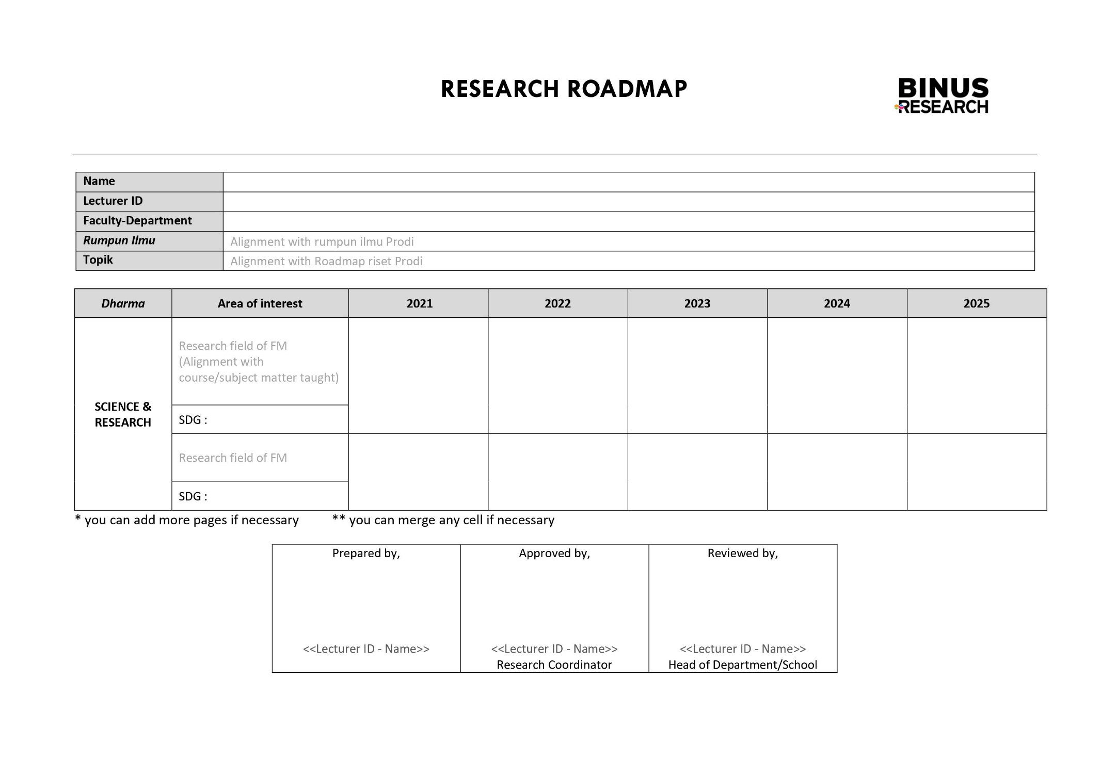

RESEARCH PRODUCT DESCRIPTION
This section contains the description of research product along with it’s function and purpose. Researchers could explain their product by attaching a picture or through a narrative description about the product

